

**15SE205J-PROGRAMMING IN JAVA**

**CSE-IIYear**

**MINI PROJECT**

***LOGIN PAGE***

***USING SWING***

**RA1511003010820 ABHISHEK SURESH**

**RA1511003010809 AYUSH CHOUDHARY**

**SEMESTER-IV**

**ACADEMIC YEAR: 2016-2017**

**Content**

1. Problem definition.
2. Problem explanation with diagram and example
3. Algorithm for the problem individual modules.
4. Explanation of algorithm with example.
5. Implementation
6. Output
7. Conclusion

**CONTRIBUTION**

|  |  |
| --- | --- |
| **Register Number** | **Contributions** |
| RA1511003010809 | Coded the main function, gave test output, and calculated performance  of required problems. |
| RA1511003010820 | Provided the code architecture, test cases, constraints, and functions used. Also debugged code and  suggested minor edits. |
|  |  |

**Problem Definition**

Aesthetic Grind.com using Swing

The problem given to us was to create a login page using swing concept in java.

Login page is created using labels,text fields and buttons.

**Problem Explanation**

The webpage is created using swing awt concept in java. Using swing web pages are designed.The login page comprises of various buttons, text field, lables that are inherited from jframe.

**Diagram**

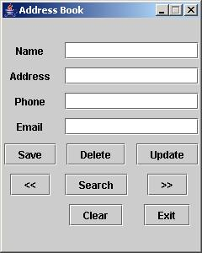

**ALGORITHM**

* **Import all the necessary header files**
* **Create a class projo and extend it using jframe**
* **Declare l1,l2,l3,l4 as jlabels**
* **Declare t1,t2 as jtextfields**
* **Declare b1 as jbutton**
* **Declare a constructor projo**
* **Declare a method set components**
* **In set components we provide all the label names,text fields and the buttons.**
* **The layout of the login page is given in the method.**
* **All the labels, textfields and buttons are added.**
* **A class handler is created which implements action listener.**
* **The main class is initialized where the name of the page is mentioned using method call.**

**The method set components is called and the program is executed.**

**Implementation**

import javax.swing.*;

import javax.swing.border.*;

import java.awt.event.*;

import java.awt.Cursor;

public class Projo extends JFrame

{

JLabel l1,l2,l3,l4;

JTextField t1,t2;

JButton b1;

JPanel p1;

JRadioButton r1;

JMenuBar m1;

JMenu m;

JMenuItem India,Overseas;

public Projo()

{

}

public Projo(String s)

{

super(s);

}

public void setcomponents()

{

ButtonGroup g=new ButtonGroup();

m1=new JMenuBar();

m=new JMenu("Territory");

r1=new JRadioButton("Forgot password?");

India=new JMenuItem("India");

Overseas=new JMenuItem("Overseas");

p1=new JPanel();

l1=new JLabel("Aesthetic Grind.com");

l2=new JLabel("Username");

t1=new JTextField();

l3=new JLabel("Password");

t2=new JTextField();

b1=new JButton("LOG IN");

l4=new JLabel();

p1.setLayout(null);

l1.setBounds(50,20,200,80);

m1.setBounds(100,150,70,20);

l2.setBounds(100,200,100,20);

t1.setBounds(210,200,100,20);

l3.setBounds(100,250,100,20);

t2.setBounds(210,250,100,20);

b1.setBounds(130,280,100,20);

r1.setBounds(130,330,200,20);

l4.setBounds(100,400,200,40);

b1.addActionListener(new Handler());

Cursor cur=new Cursor(Cursor.HAND_CURSOR);

b1.setCursor(cur);

r1.setMnemonic(KeyEvent.VK_C);

g.add(r1);

add(r1);

m.add(India);

m.add(Overseas);

m1.add(m);

add(m1);

add(l1);

add(l2);

add(t1);

add(l3);

add(t2);

add(b1);

add(l4);

}

class Handler implements ActionListener

{

public void actionPerformed(ActionEvent e)

{

l4.setText("Password is incorrect");

}

}

public static void main(String args[])

{

Projo jf=new Projo("Aesthetic Grind");

jf.setcomponents();

jf.setVisible(true);

jf.setDefaultCloseOperation(JFrame.EXIT_ON_CLOSE);

jf.setSize(600,600);

}

}

**Screenshot**

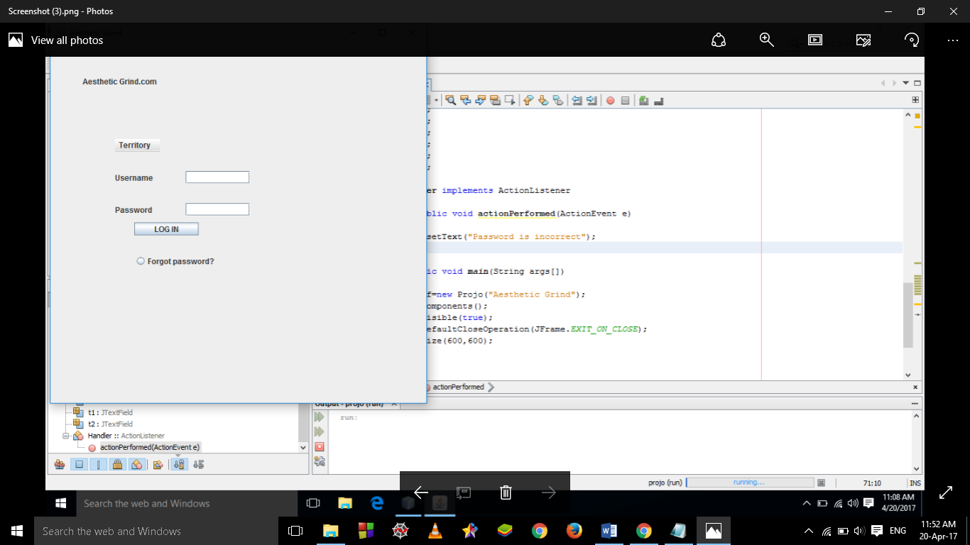

CONCLUSION

We created a login page for the website aesthetic grind.com.We used various classes such as jframe classes to make buttons, text fields and

Lables.The website asks for username and password and prints password is incorrect if dosent match with the correct one.